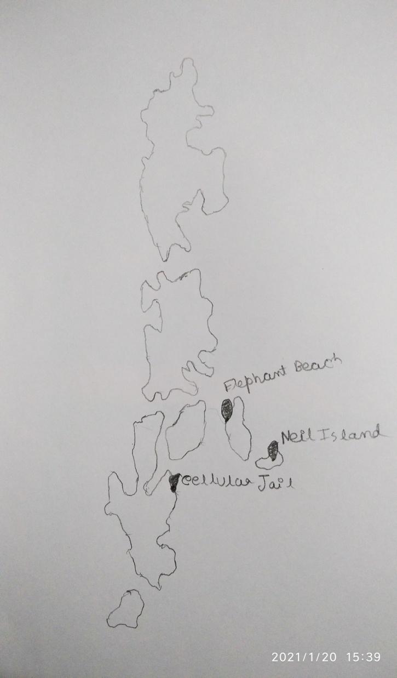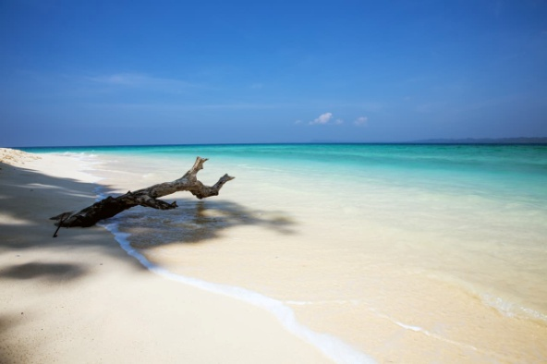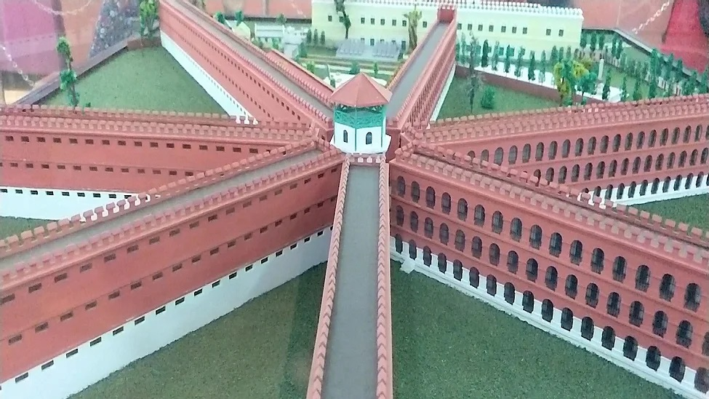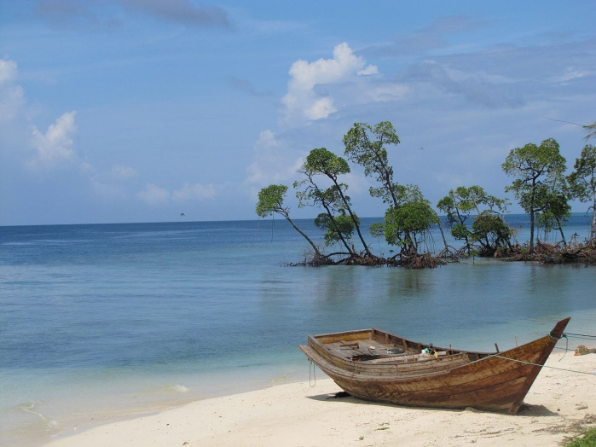

***English Project Work***

*Name:-* ***Arnab Chatterjee***

*Class :-* ***XI-Sc***

*Sub:-* ***English***

**Last year I had done a sea voyage to Andaman & Nicobar Islands with my family.**

**The Voyage was truly amazing. It took about 4 days to reach there. My father had done the booking**

**from one of the shipping corporation offices in Kolkata. The booking process was very tedious as no online booking facility was available.**

**By doing that Voyage I was benefitted as I was able to know different facts and culture of Andaman and Nicobar Islands.**

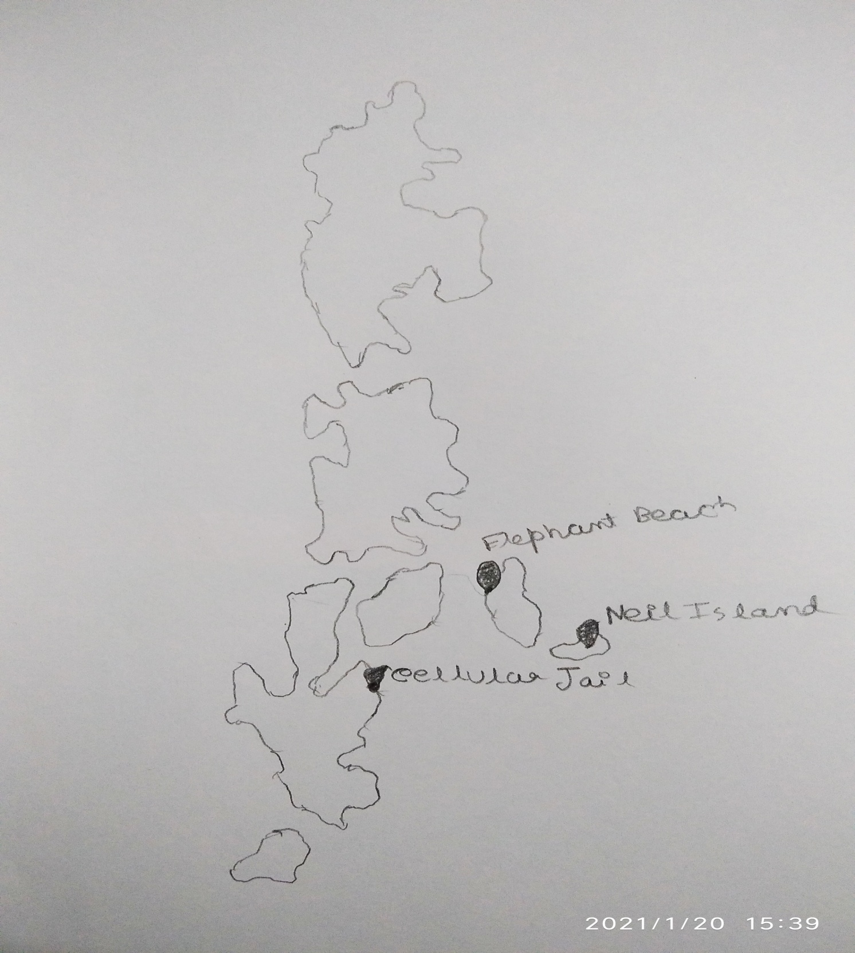

**This is a map of Andaman & Nicobar Island .The places are marked which we had visited. The places are:-**

* **Cellular jail.**
* **Elephant Beach**
* **Neil Island.**



**So the first we visited was Cellular jail. The facts we came to know is truly amazing.**

**The Cellular Jail, also known as Kālā Pānī (Hindi for *black waters*), was a colonial prison in the Andaman and Nicobar Islands, India. The prison was used by the British for the express purpose of exiling political prisoners to the remote archipelago.**

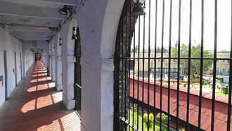**The construction of the prison started in 1896 and was completed in 1906. The original building was a puce-coloured brick building. The bricks used to build the building were brought from Burma.**

**The building had seven wings, at the center of which a tower served as the intersection and was used by guards to keep watch on the inmates; this format was based on Jeremy Bentham's idea of the Panopticon. The wings radiated from the tower in straight lines, much like the spokes of a bicycle wheel.**

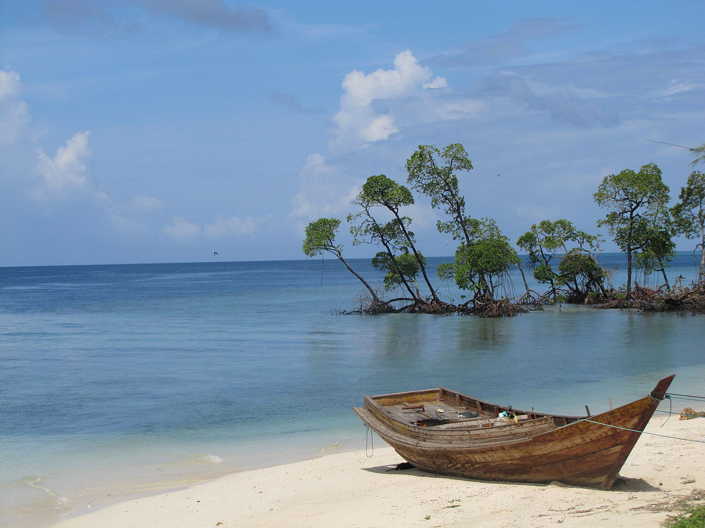

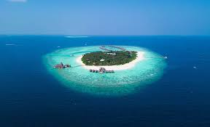**Then we visited Elephant beach means the Havelock Island. Havelock Island, officially Swaraj Island, is one of the largest islands in Ritchie's Archipelago, to the east of Great Andaman within the Andaman Islands. It belongs to the South Andaman administrative district, part of the Indian union territory of Andaman and Nicobar Islands. The island is 41 km (25 mi) northeast of the capital city, Port Blair.**

**Havelock is one of the few places that the administration of the Andaman and Nicobar Islands union territory of India has permitted and encouraged development of tourism, with a focus on promoting** [**eco-tourism**](https://en.wikipedia.org/wiki/Eco-tourism)**.**

**Havelock Island avoided much of the devastation by the** [**2004 Indian Ocean earthquake**](https://en.wikipedia.org/wiki/2004_Indian_Ocean_earthquake) **and its resulting** [**tsunami**](https://en.wikipedia.org/wiki/Tsunami) **and there were no documented casualties.**

**There is a** [**lighthouse**](https://en.wikipedia.org/wiki/Havelock_Island_lighthouse) **at the northern point of the island, near Govinda Nagar, established in 2005.**

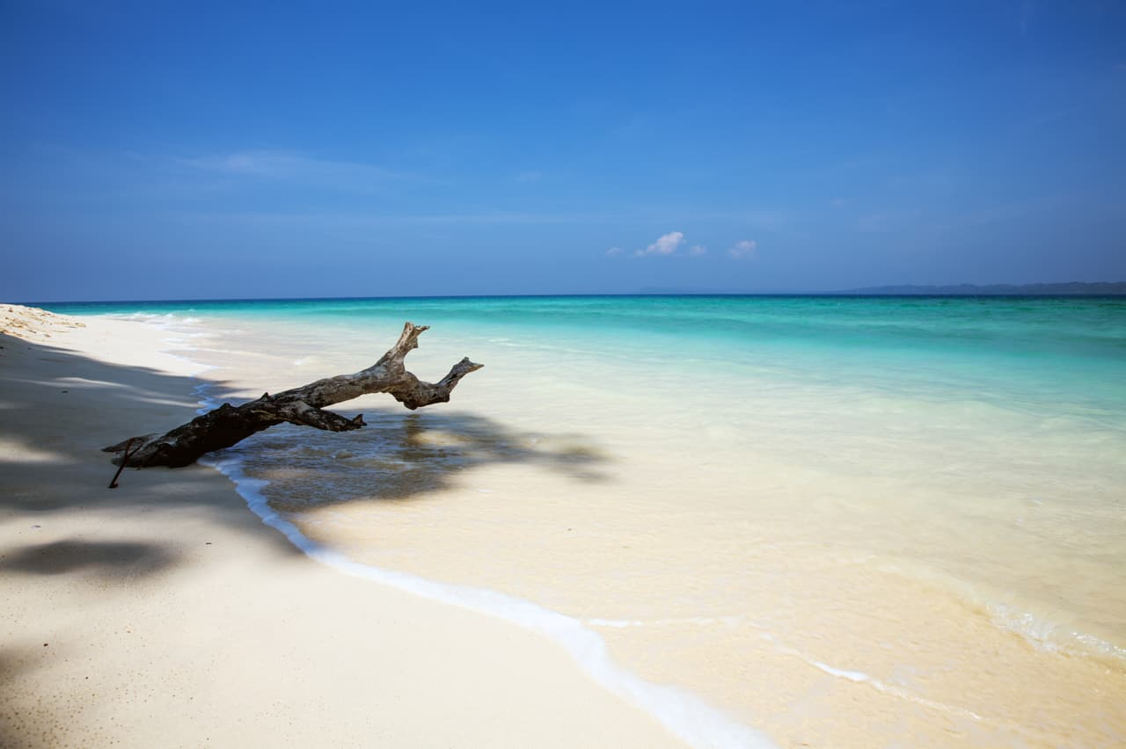

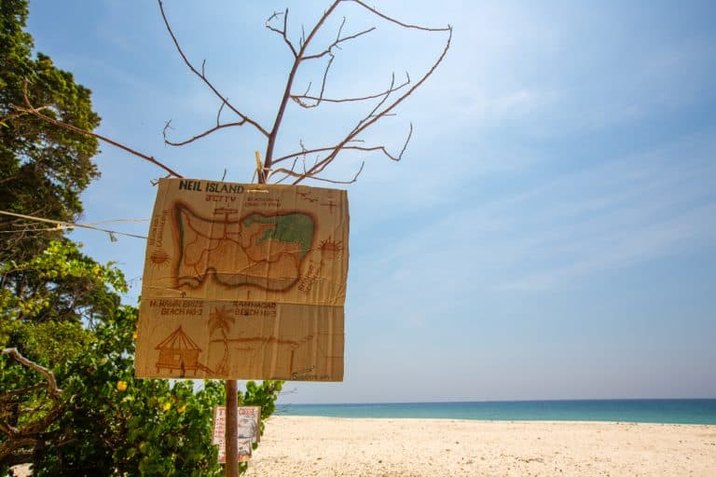**The last place we visited was Neil Island.**

**Known for its magnificent biodiversity, unexplored coral reefs, white sandy beaches, and tropical woodlands, Neil Island is perfect for a peaceful time off. This Island has an area of 13.7 square kilometers only. Given the flat landscape and the small area, Neil can be bicycled around with minimal effort. With its laid-back vibe, and lucid charm the island is soothingly different from its neighboring Havelock.**

